The Distressed Communities Index (DCI), developed by Economic Innovation Group (EIG), takes seven measures from the U.S. Census Bureau, ranks each zip code on each measure, averages the ranks, and then ranks the average. Here is an example from San Antonio.

Zip code 78217 borders Loop 410 to the north and is between the San Antonio International Airport and Morgan’s Wonderland.

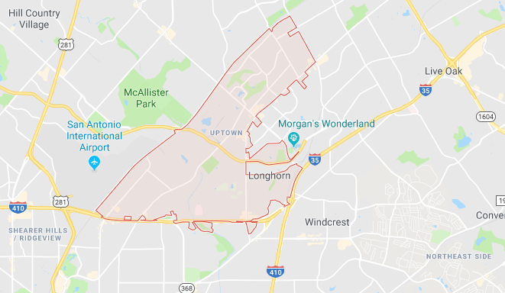

|  |  |  |
| --- | --- | --- |
| Zip Code 78217 | Value | Rank Among 26,125 Zip Codes  (Lower is better) |
| Adults Without High School Diploma | 9.6% (Lower is better) | 10,753 |
| Vacant Housing Units | 9.7% (Lower is better) | 16,064 |
| Adults Without Jobs | 22.8% (Lower is better) | 7,263 |
| People Below Poverty Level | 17.4% (Lower is better) | 17,531 |
| Median Income Compared to State | 85.6% (Higher is better) | 16,501 |
| Change in Number of Jobs 2011 – 2015 | 15.6% (Higher is better) | 7,642 |
| Change in Number of Businesses 2011 – 2015 | –2.0% (Higher is better) | 17,629 |
| Average of seven ranks |  | 13,340 |

The average of the seven ranks is 13,340.43. The average of the seven ranks for all the U.S. zip codes ranges from 652 to 25,771. Zip code 78217 ranks 13,518 out of 26,125, which puts it at the 51.7 percentile – very close to the nationwide median.

There is a graph below of the average of the DCI ranks (13,340.43 for zip code 78217) versus the rank of the averages (13,518 for zip code 78217). There are a few aspects of it to note.

First, the shape is a line that curls down on the left and curls up on the right. The straight part of the line represents about 23,000 zip codes in which each one is just slightly richer than the one after it. There are about 1000 very rich zip codes (on the left) in which each one is significantly richer than the one after it, and about 2000 very poor zip codes (on the right) in which each one is significantly poorer than the one before it.

(The terms “rich” and “poor” are not strictly accurate in this context; there are only two out of seven DCI components that relate to income and none that relate to wealth. We use these terms as abbreviations for “communities with high economic well-being” and “communities with low economic well-being.”)

Second, the chart highlights the zip codes of three cities:

|  |  |  |
| --- | --- | --- |
| Name | Population | Rank in U.S. |
| Phoenix, Arizona | 1,563,025 | 6 |
| San Antonio, Texas | 1,469,845 | 7 |
| San Diego, California | 1,394,928 | 8 |

Third, San Antonio zip codes are spread throughout the distribution, from almost the richest to almost the poorest. However, Phoenix has an even wider spread. San Diego tops out lower than the richest zip codes in Phoenix or San Antonio but bottoms out greatly above the other two cities. Therefore, income inequality in these three cities *seems* highest in Phoenix, lowest in San Diego, before adjusting for the populations of the zip codes.

